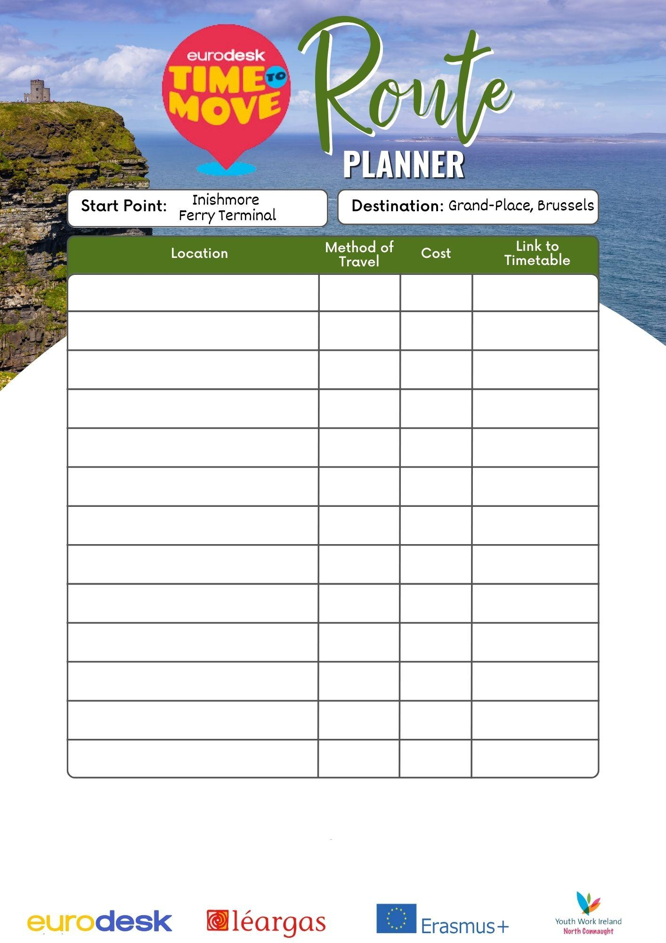

|  |  |  |  |  |  |  |
| --- | --- | --- | --- | --- | --- | --- |
| **Stage of Journey** | **Method of Travel** | **Time Taken** | **Cost** | **Carbon Emissions** | **Accessibility Options** | **Link to Timetable** |
|  |  |  |  |  |  |  |
|  |  |  |  |  |  |  |
|  |  |  |  |  |  |  |
|  |  |  |  |  |  |  |
|  |  |  |  |  |  |  |
|  |  |  |  |  |  |  |
|  |  |  |  |  |  |  |
|  |  |  |  |  |  |  |
|  |  |  |  |  |  |  |
|  |  |  |  |  |  |  |
|  |  |  |  |  |  |  |
|  |  |  |  |  |  |  |
|  |  |  |  |  |  |  |
|  |  |  |  |  |  |  |
| **Total Time, Cost & CO2 Emissions:** |  |  |  |  |  |  |
| **Entrant Details** |  | | | | | |